**Fourier Series**

If a function is periodic,



Then the function can be written as



K=1 is the fundamental frequency. All the other frequencies are the harmonics of this fundamental frequency.

Joseph Fourier suggested that we can write this function as a sum of sine and cosine harmonics

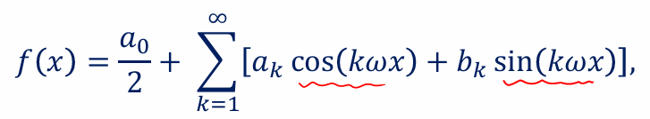

Derivation included in the derivation notes

Alternative forms:

**Even & Odd Functions**

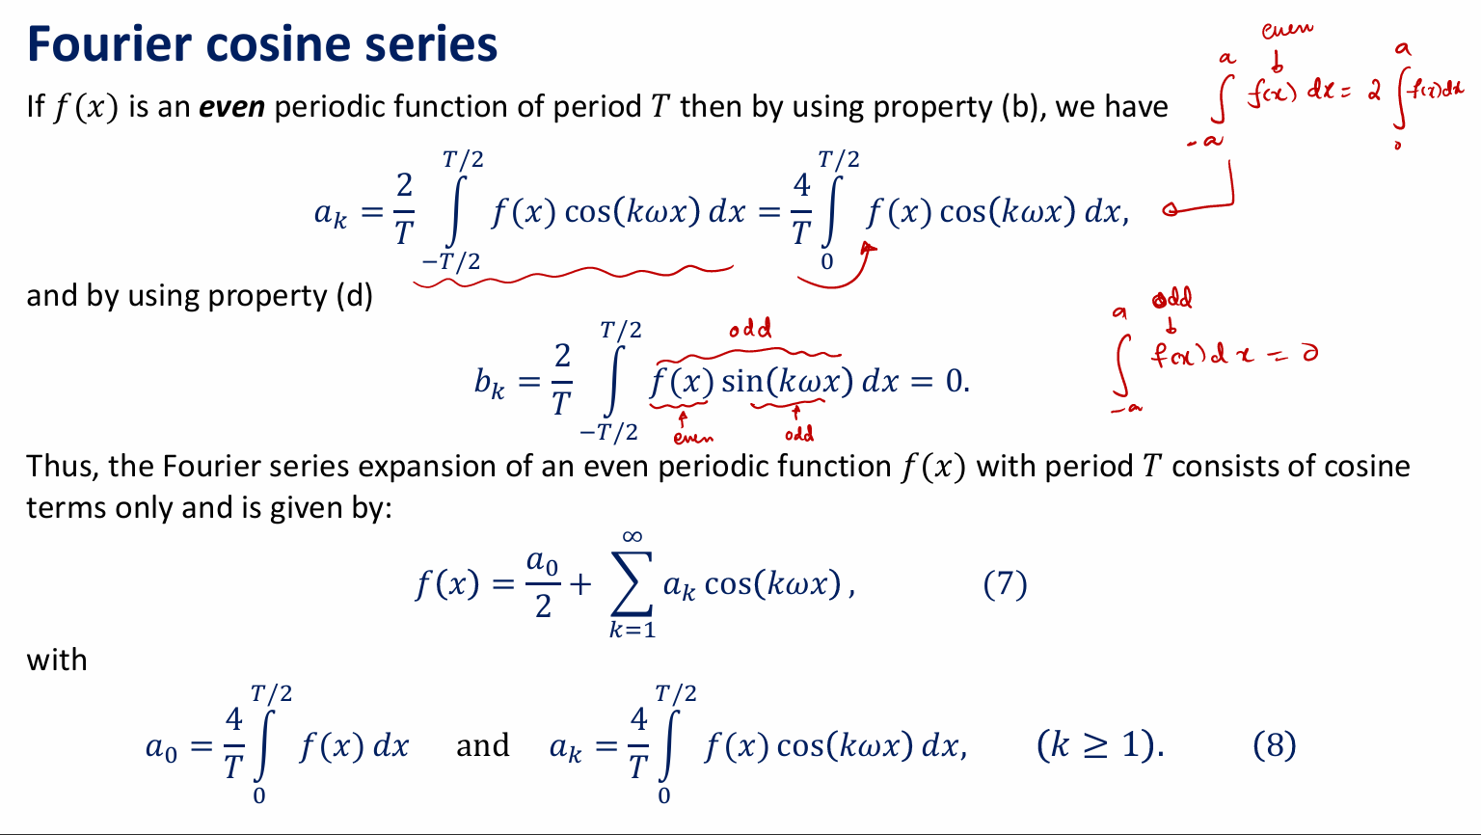

**Conditions for existence and convergence of fourier series**

**How can we find the transform of non-periodic functions?**

1. **Half range expression**
2. **Fourier Transforms**

**Half Range Expansion**

**Even Expansion**

**Odd Expansion**

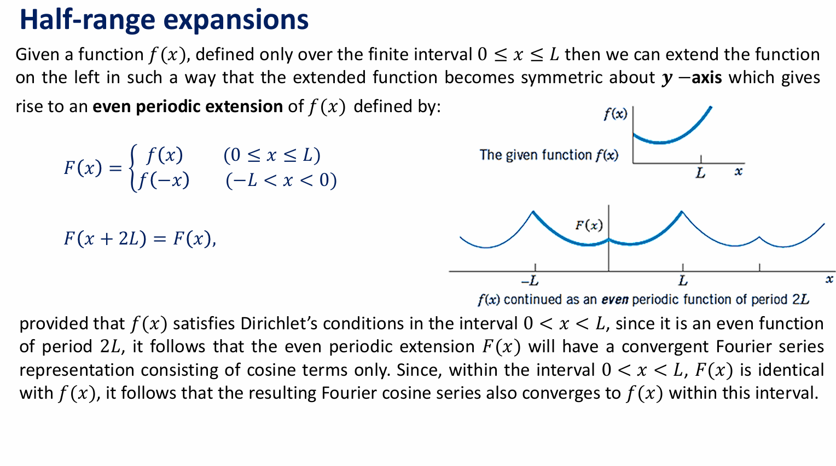

Complex Fourier Series

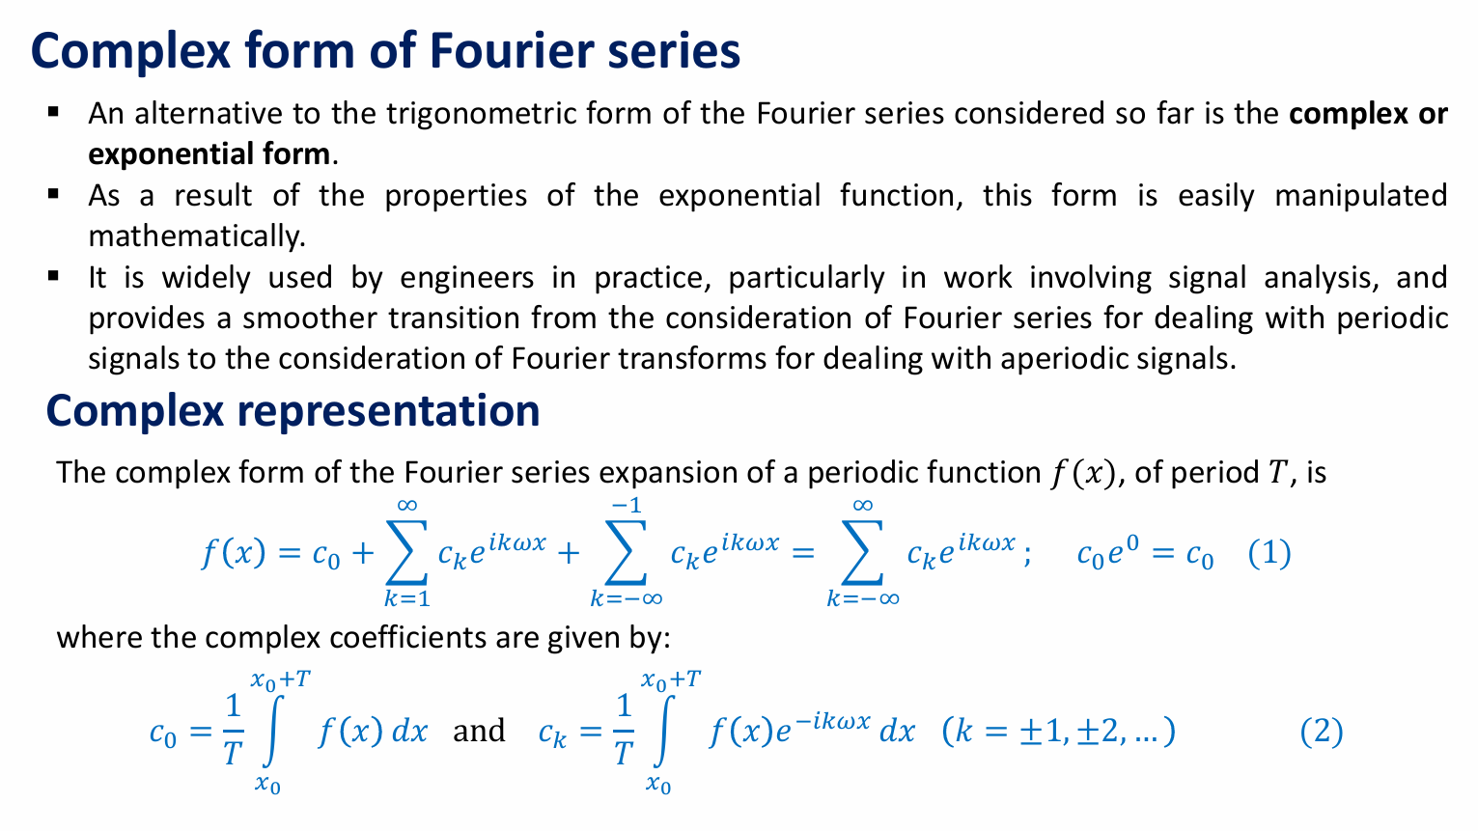

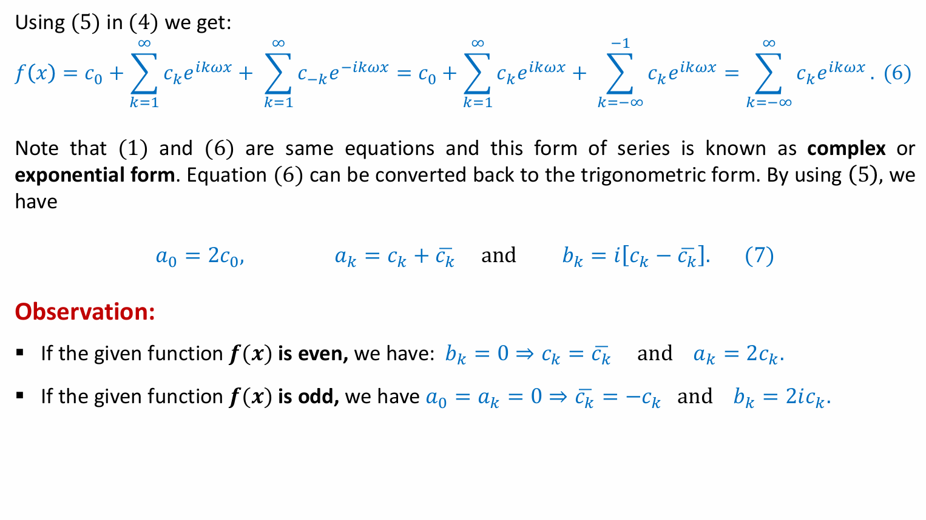

Fourier Integrals

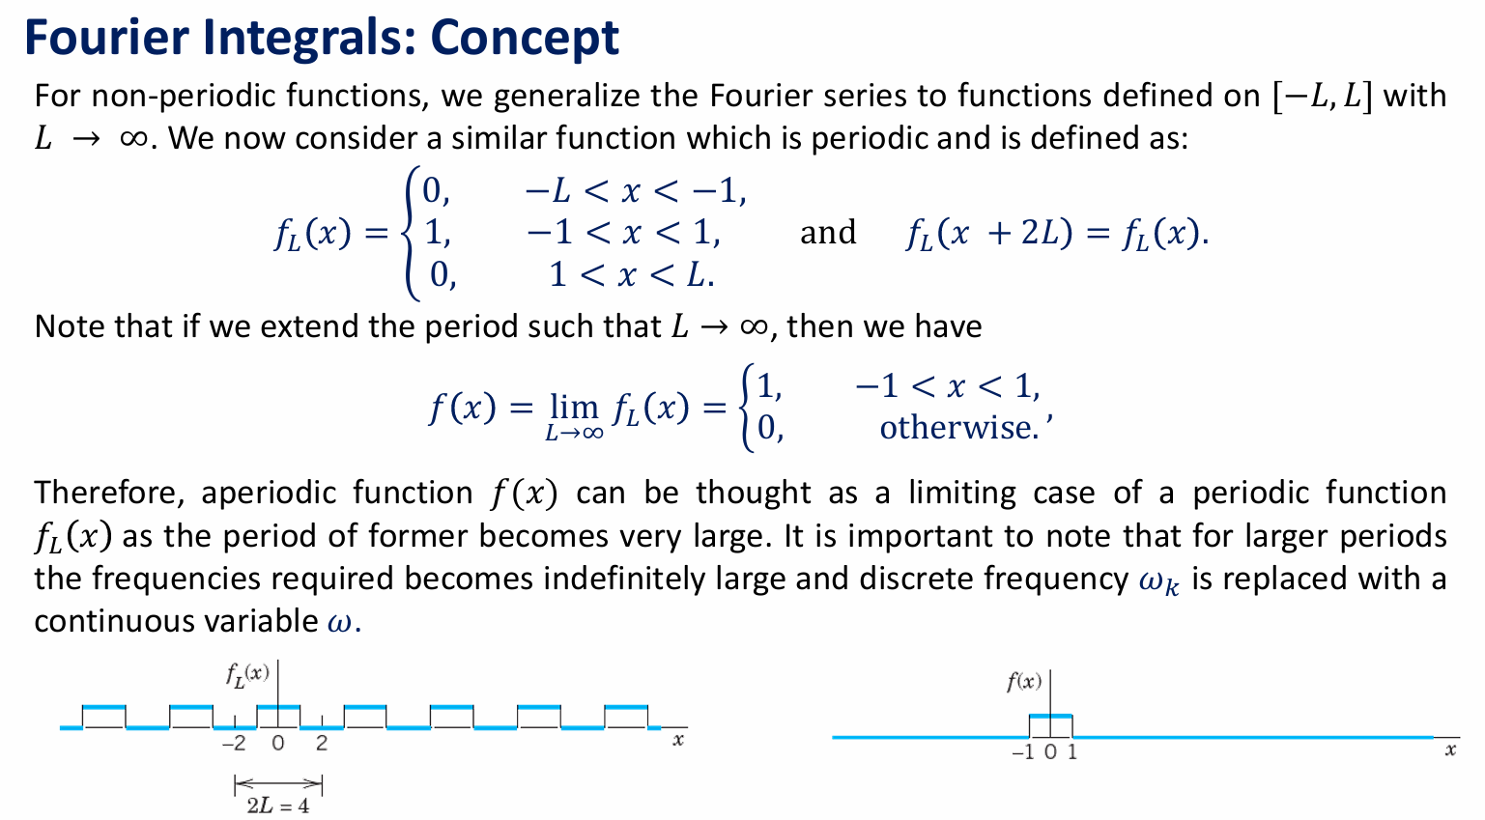

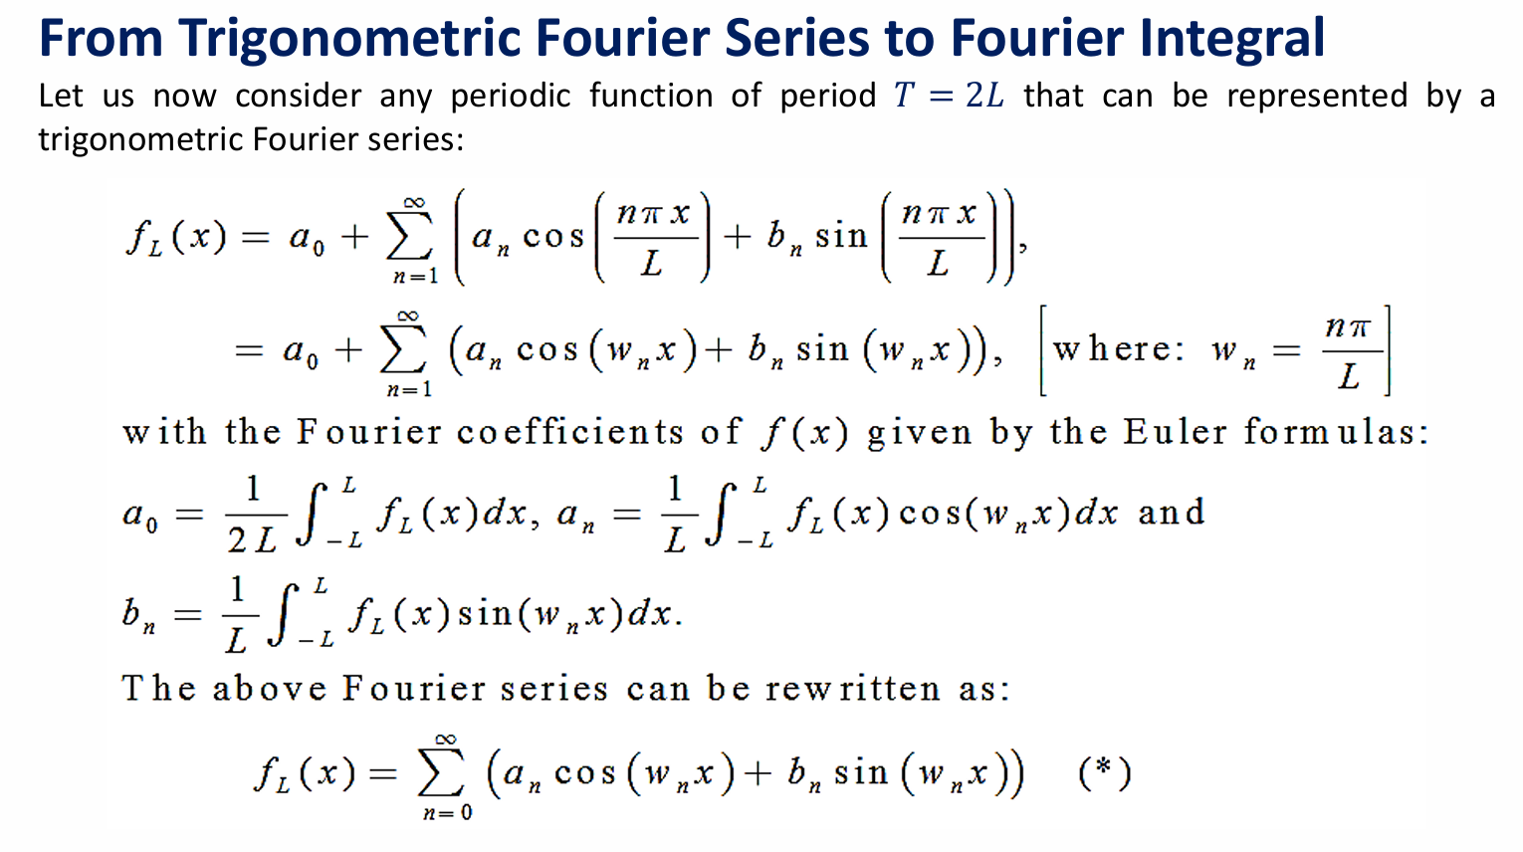

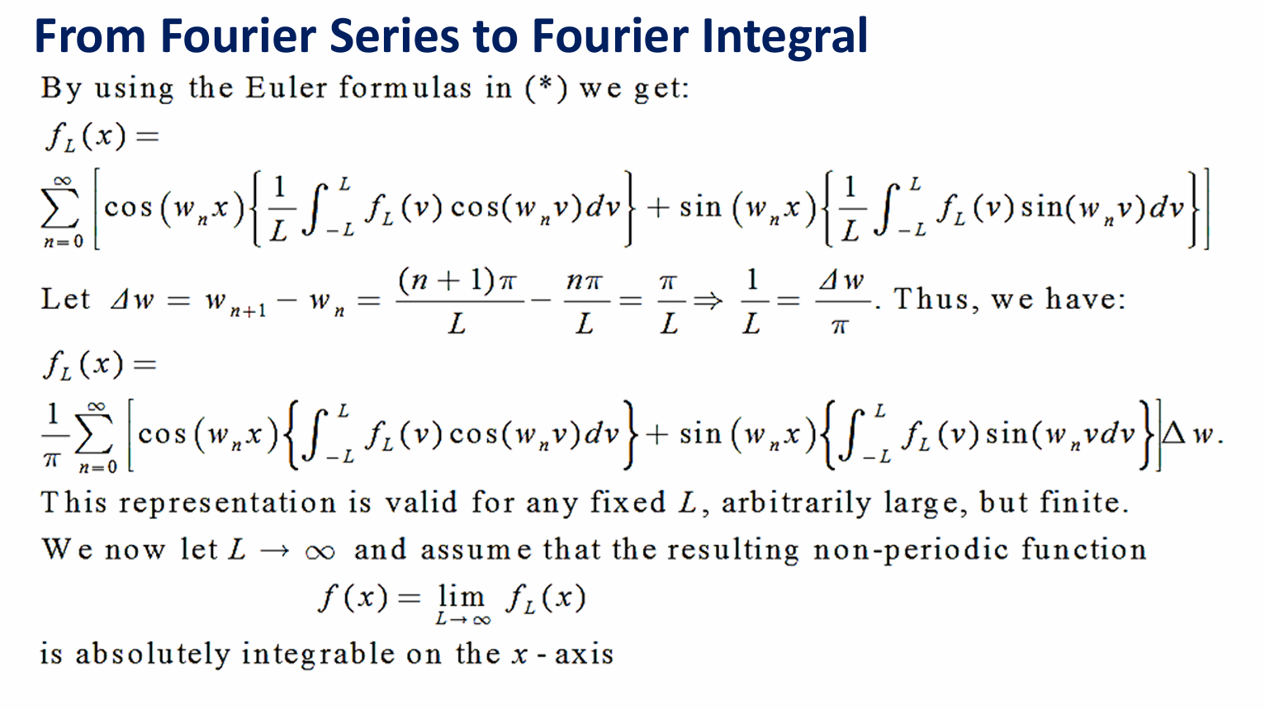

Fourier Transform



